Ocinebrina paddeui Bonomolo & Buzzurro, 2006

Scheda tassonomica:
Classis | Gastropoda Cuvier, 1797
Ordo | Neogastropoda Thiele, 1929
Superfamilia | Muricacea Rafinesque, 1815
Familia | Muricidae Rafinesque, 1815
Subfamilia | Ocenebrinae Cossmann, 1903
Genus | Ocinebrina Jousseaume, 1880
Subgenus
specie | paddeui Bonomolo G. & Buzzurro G., 2006
subspecie

Scheda descrittiva:
Sinonimi | -
Descrizione | (vedi descrizione originale)
Dimensioni | (vedi descrizione originale)
Area di distribuzione e habitat | Conosciuta solo per il locus typicus: Alghero (SS), Mar delle Baleari, -80/120 metri, su Corallium rubrum.
Descrizione originale | Olotipo: Shell of middle-small size (13,1 x 6 mm), solid and fusiform, composed by about 6,50 spiral whorls (Figs 1-3), of which 1,15 are protoconch whorls, that appears to be paucispiral, mamillate, elevated, globose, elongate, smooth, translucent, with obvious growth lines (Figs 4-5). Teleoconch of 5,35 slightly convex whorls, narrow, with superficial suture and shoulder little angled, that give it a slender general aspect, not scalariform. The first, second and the third teleoconch whorls are composed by 9 axial ribs and 3 primary cords, the fourth ones by 9 axial ribs, 3 primary cords and 4 secondary threads. The body-whorl represents about ⅔ of the total height, and it is ornamentated by an axial sculpture consisting of 7 low ribs, more prominent in the median part, that become almost obsolete in proximity of the siphonal canal; at about half whorl there is an ex-labial nodose varix. Spiral sculpture constituted by 9 primary cords, low and weak, placed side by side and alternated by a smaller secondary cord. The primary cords are distributed: 1 in the infrasutural ramp, 6 in the convex part of the whorl and 2 on the siphonal canal. Outer lip crenulate, erect, with 5 denticles within, and with a nodose varix in the superior part, narrow and little high. Aperture ovate, narrow, elongate, of shiny white colour, and the submedian brownish belt crossing the spiral whorl shines through in the inner part. Columellar lip smooth, shiny, adherent, slightly expanded ventrally, and weakly erect abapically. Columella straight. Siphonal canal moderately long, straight, back-turned, and ventrally sealed. External colour pattern with spiral bands, characterized by a first brown band in the infrasutural zone, followed in the median part of the whorl by another one more broad and white in colour, well visible also in the preceding whorls, and therefore followed by a brown band similar to the first one, and finally by a clearer, but not white, band in proximity of the siphonal canal.
Riferimenti bibliografici | - Bonomolo G. & Buzzurro G., 2006. Description of a new muricid for the Mediterranean Sea: Ocinebrina paddeui (Mollusca, Gastropoda, Muricidae: Ocenebrinae) Triton 13: 1-4;
Riferimenti on line | -http://www.naturamediterraneo.com/forum/topic.asp?TOPIC_ID=12045
Comparazione | Differisce dalle congeneriche per la forma dei giri di spira meno scalati, più stretti ed allungati, così come l’apertura, e per la struttura della protoconca con evidenti strie di accrescimento.
Note | La specie presenta una costanza di forma e colore.
Redattore | Scheda di Giuseppe Bonomolo – aggiornata al 24/09/2006

Scheda fotografica:
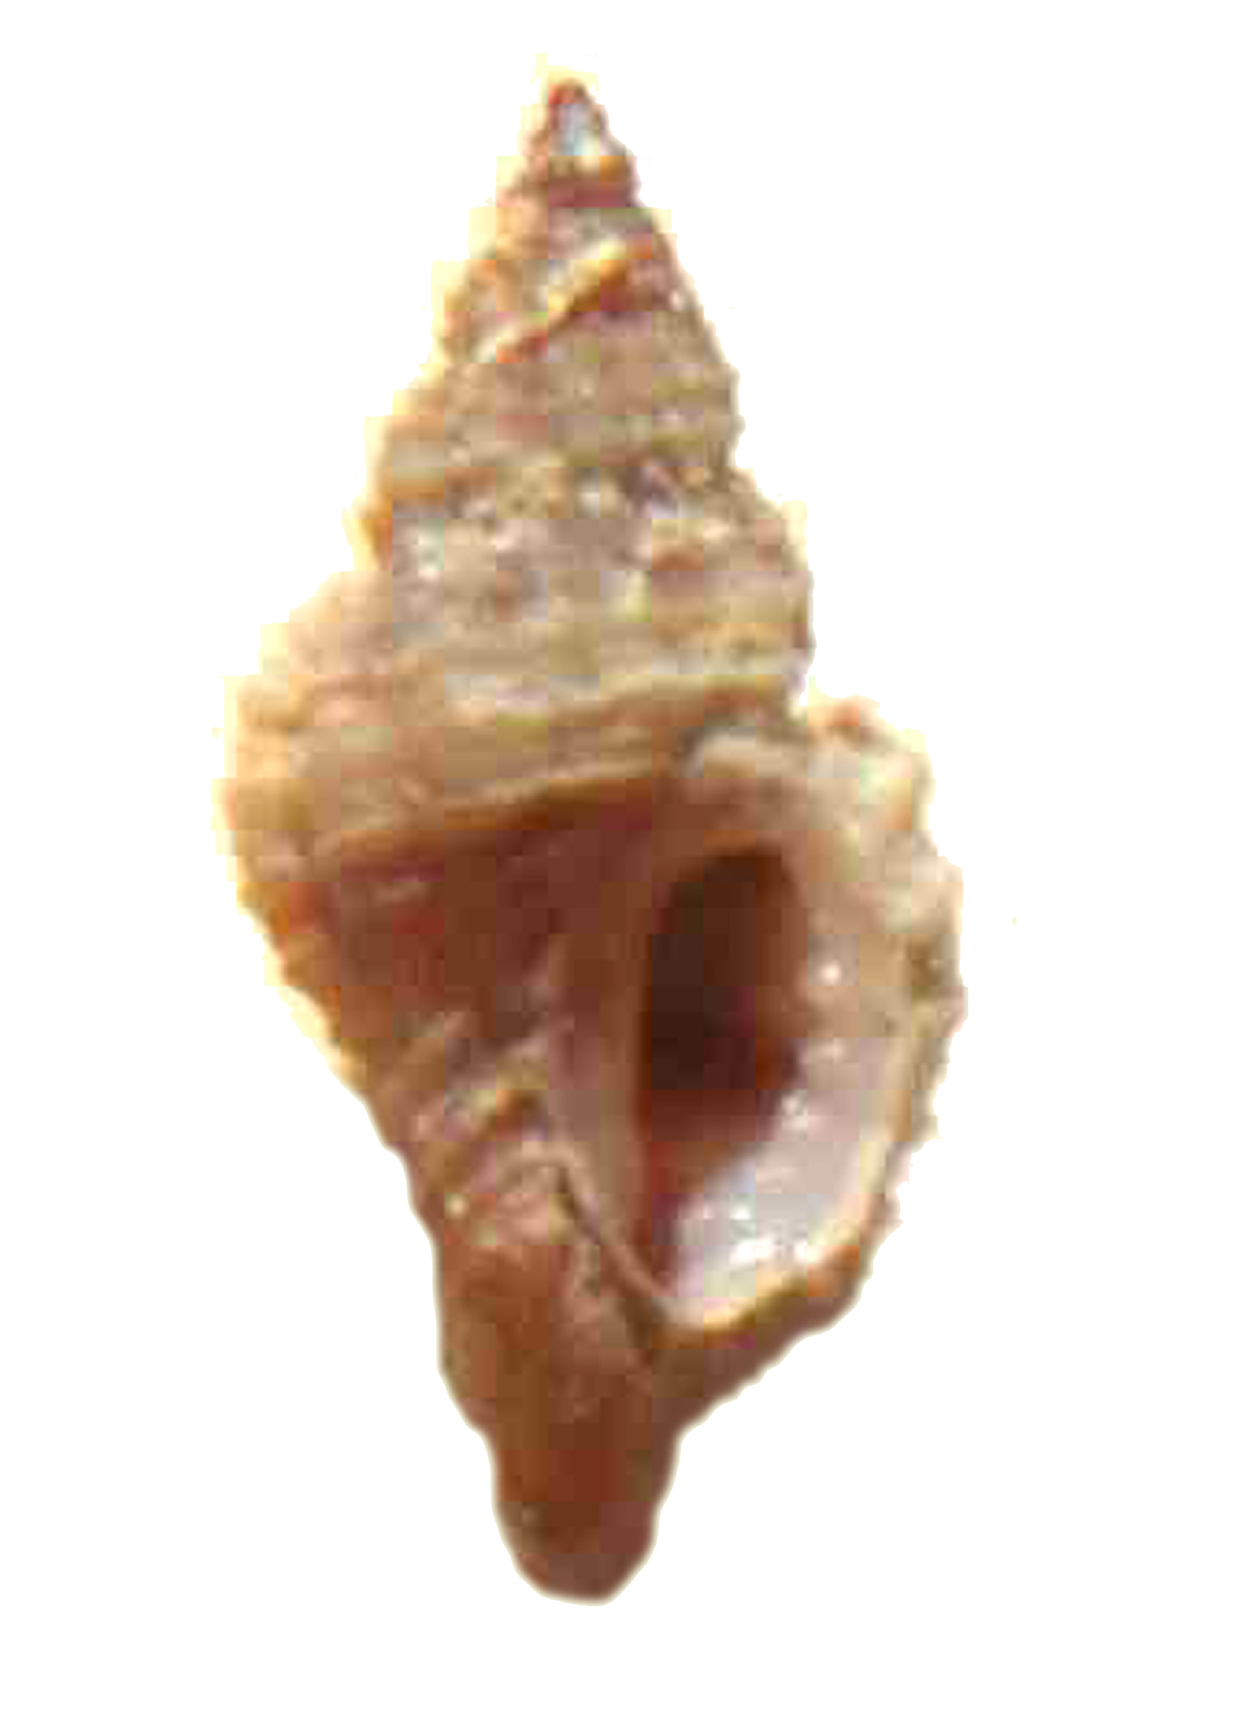
f./var.
provenienza | Alghero, -100/120 metri
misure | ca. 12 mm
Note | Foto di Maria Teresa Spanu  Esemplare di Maria Teresa Spanu

